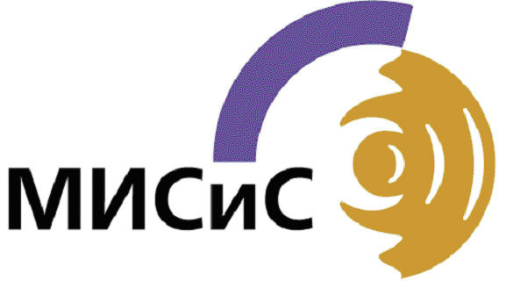
National University of Science and Technology
«MISIS»

Application Form for the 6th International Students’
Conference «Study and Achieve»
November 19 – 25, 2012

The name of your University

Personal tails

Family name
First name
Sex
Country

Contact details

E-mail address
Phone number
(incl. code of the country

Presentation

The title of presentation
Language | English | German | French

Application form should be sent to MISIS before October 21th, 2012 by
e-mail: m.kosyreva@misis.ru (with a copy to t.koroleva@misis.ru)

