Christophe Défossez

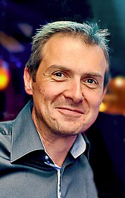
Christophe Défossez has been working in Moscow since March 2005 in the French company specialized in low and medium voltage electrical equipments, Schneider Electric. His current position is Head of Purchasing team for projects.
Christophe Défossez was born in Cambrai ( town located in the north of France) and studied nearby in Valenciennes where he got an engineering degree. He then went to ENSAM-Paris (Ecole Nationale des Arts et Métiers) to follow an MBA specialized in Quality management. His professional background in France before joining Schneider Electric was mainly in the automotive industry as Quality manager.
Christophe will give a short talk expressing his view as a professional on the role of the French language in doing business around the globe. The talk will be in English, but the questions and answers session that follows will be both in English and in French.

